Project Design Phase
Solution Architecture
Date | 3 October 2026
Team ID | SWTID-2026-9505
Project Name | Implement Client Script & UI Policy (Incident) - ServiceNow
Maximum Marks | 4 Marks
Solution Architecture:
Solution architecture is a complex process – with many sub-processes – that bridges the gap between business problems and technology solutions. Its goals are to:
- Find the best tech solution to solve existing business problems.
- Describe the structure, characteristics, behavior, and other aspects of the software to project stakeholders.
- Define features, development phases, and solution requirements.
- Provide specifications according to which the solution is defined, managed, and delivered.
Example - Solution Architecture Diagram:
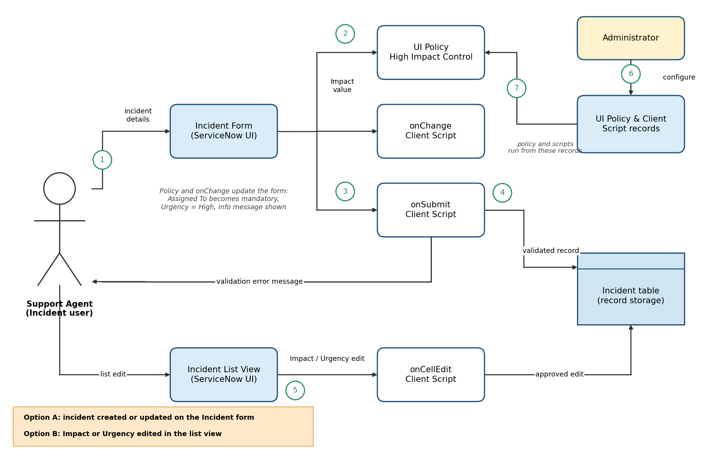
Figure 1: Architecture and data flow of the Incident form validation solution in ServiceNow
Flow: (1) Agent enters incident details. (2) UI Policy and onChange script react to Impact. (3) onSubmit script validates on save. (4) Valid records are saved, otherwise an error is shown. (5) List edits are checked by onCellEdit. (6)-(7) The administrator configures the policy and scripts, which run from stored records.
Reference: ServiceNow product documentation (docs.servicenow.com): UI Policies and Client Scripts

